**INTRODUCTION TO RELATIONAL, LOGICAL**

**OPERATORS, SELECTION STATEMENTS**

**LAB # 3**



**Spring 2022**

**CSE102L Computer Programming Lab**

Submitted by: **Ali Asghar**

Registration No. : **21PWCSE2059**

Class Section: **C**

“On my honor, as student of University of Engineering and Technology, I have neither given nor received unauthorized assistance on this academic work.”

Student Signature: ______________

Submitted to:

**Engr. Abdullah Hamid**

July 4, 2022

Department of Computer Systems Engineering

University of Engineering and Technology, Peshawar

**Lab Objective(s)**

* To be familiar with Relational & Logical Operators
* To understand the programming knowledge using Selection Statements (if, if-else, if-else ladder, Nested if-else and Switch)

**TASK # 1:**

**Title:**

Display the largest among three numbers using if else statement?

**CODE SCREENSHOTS:**

Here are the screenshots of the code.

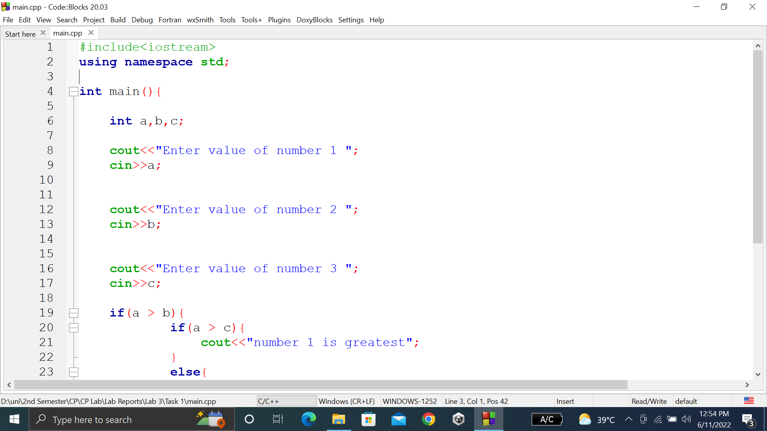

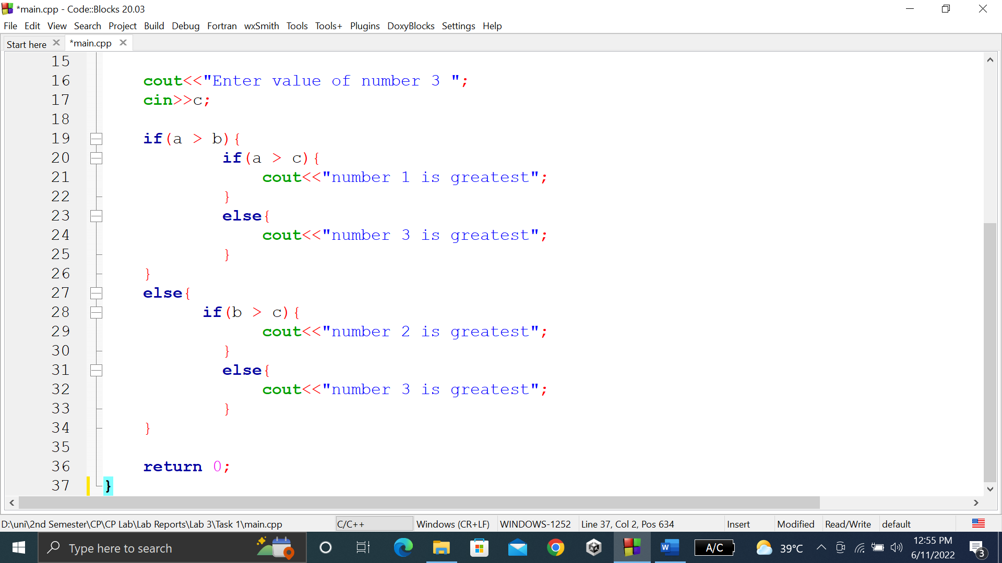

### **OUTPUT (COMPILATION, DEBUGGING & TESTING):**

Here is the screenshot of the output of above code.

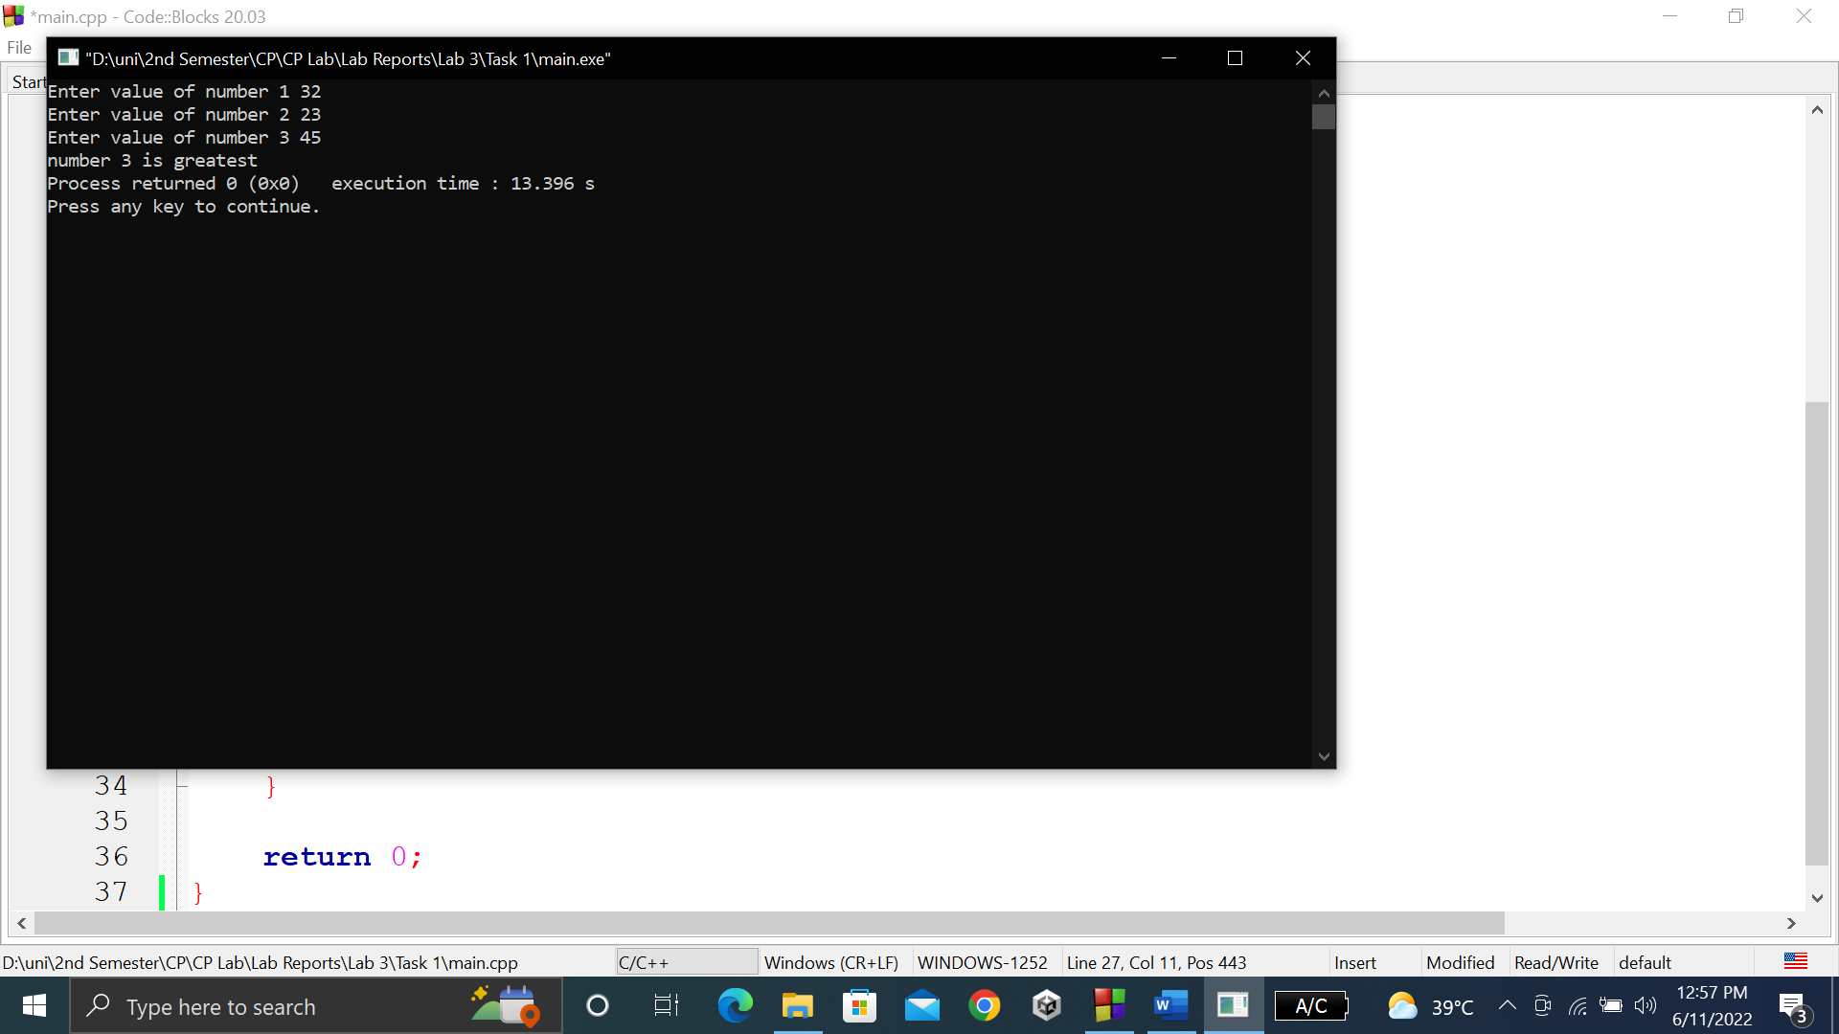

**TASK # 2:**

**Title:**

Check whether a number is even or odd?

**CODE SCREENSHOTS:**

Here is the screenshot of the code.

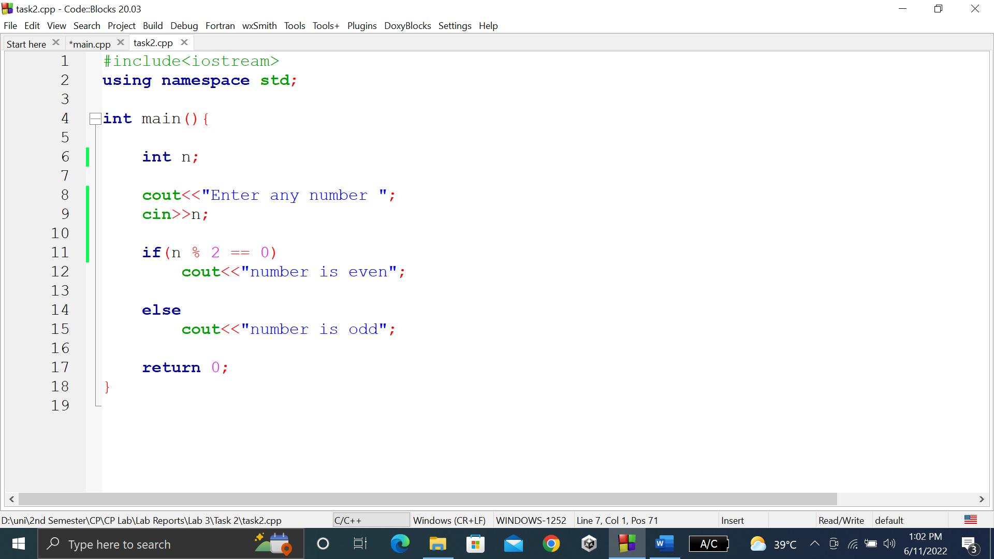

### **OUTPUT (COMPILATION, DEBUGGING & TESTING):**

Here are the screenshots of the output of above code.

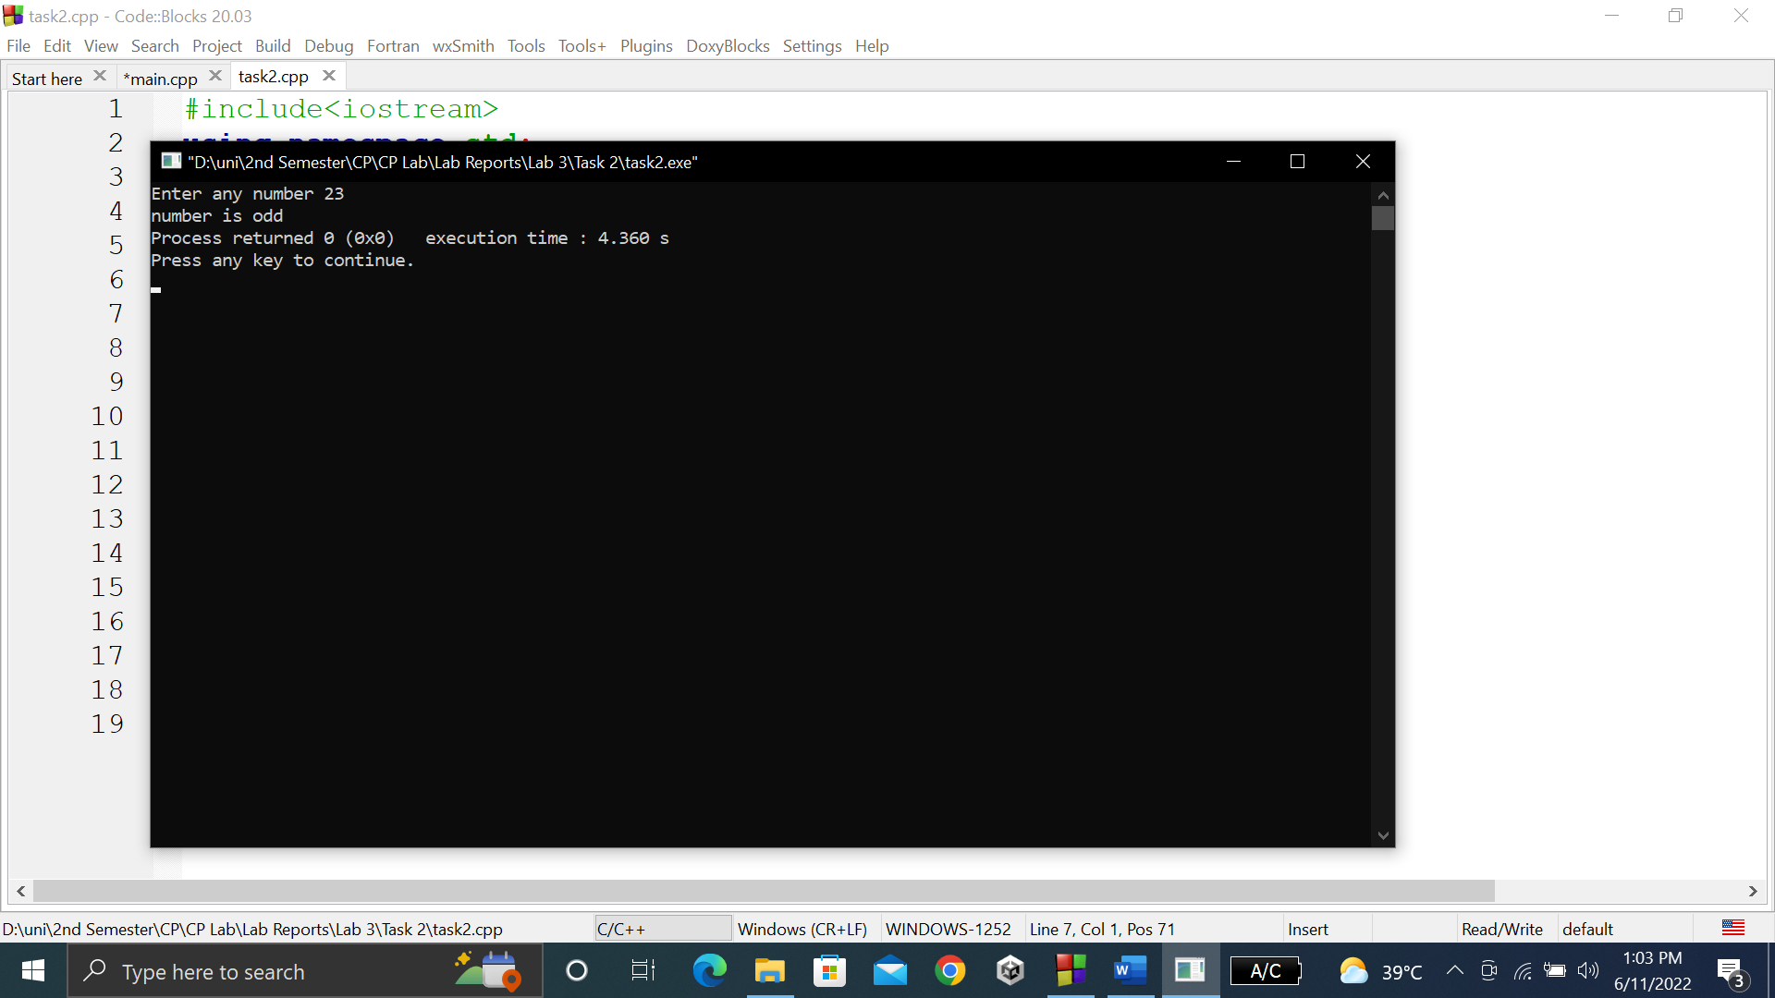

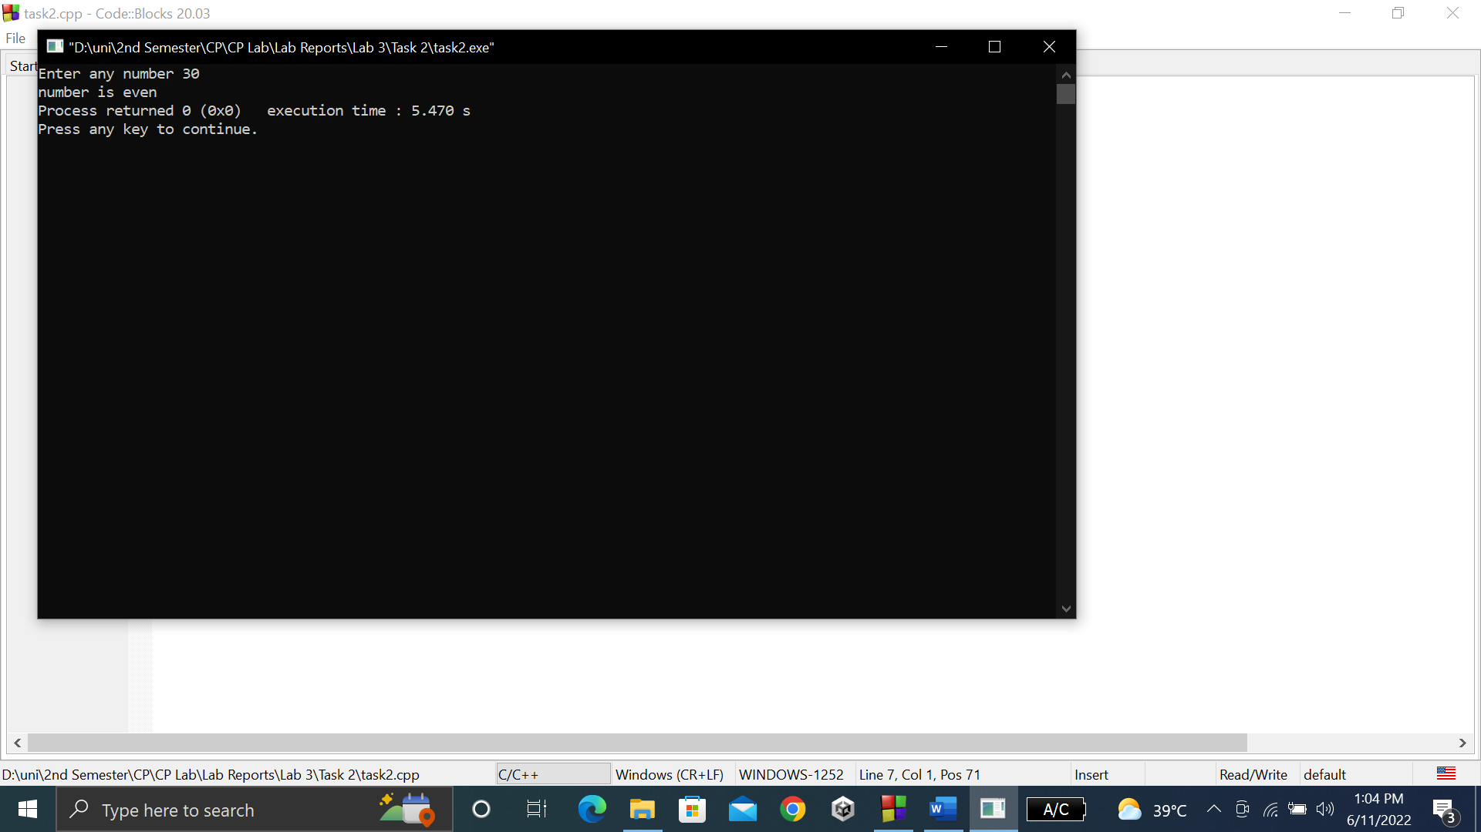

**TASK # 3:**

**Title:**

Check the greater of two numbers using ternary operator?

**CODE SCREENSHOTS:**

Here is the screenshot of the code.

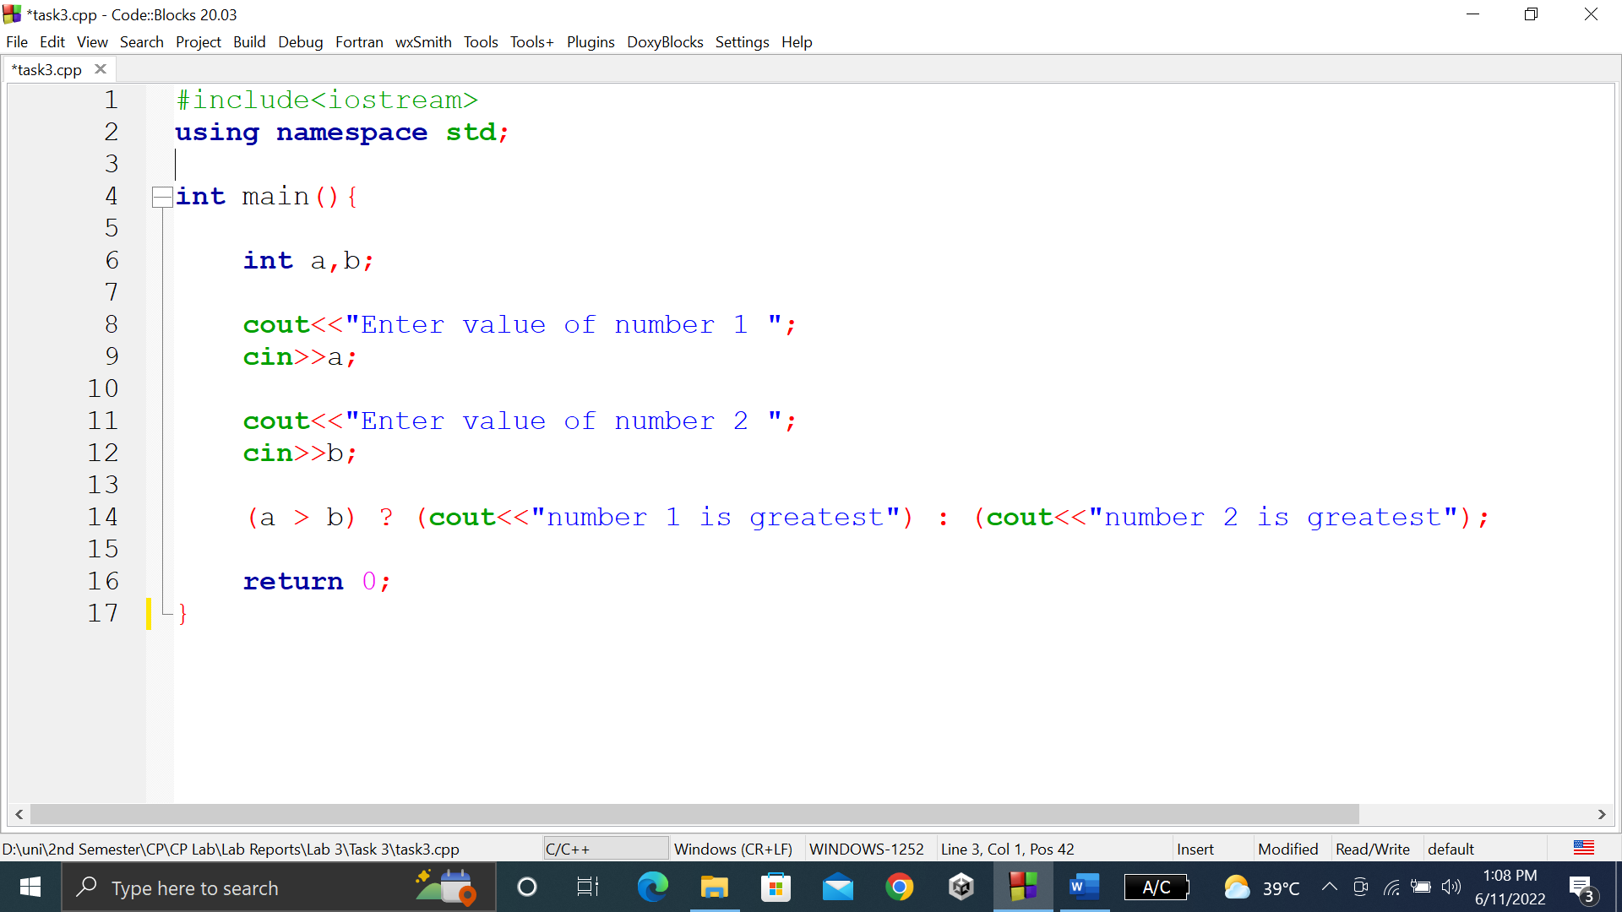

### **OUTPUT (COMPILATION, DEBUGGING & TESTING):**

Here is the screenshot of the output of above code.

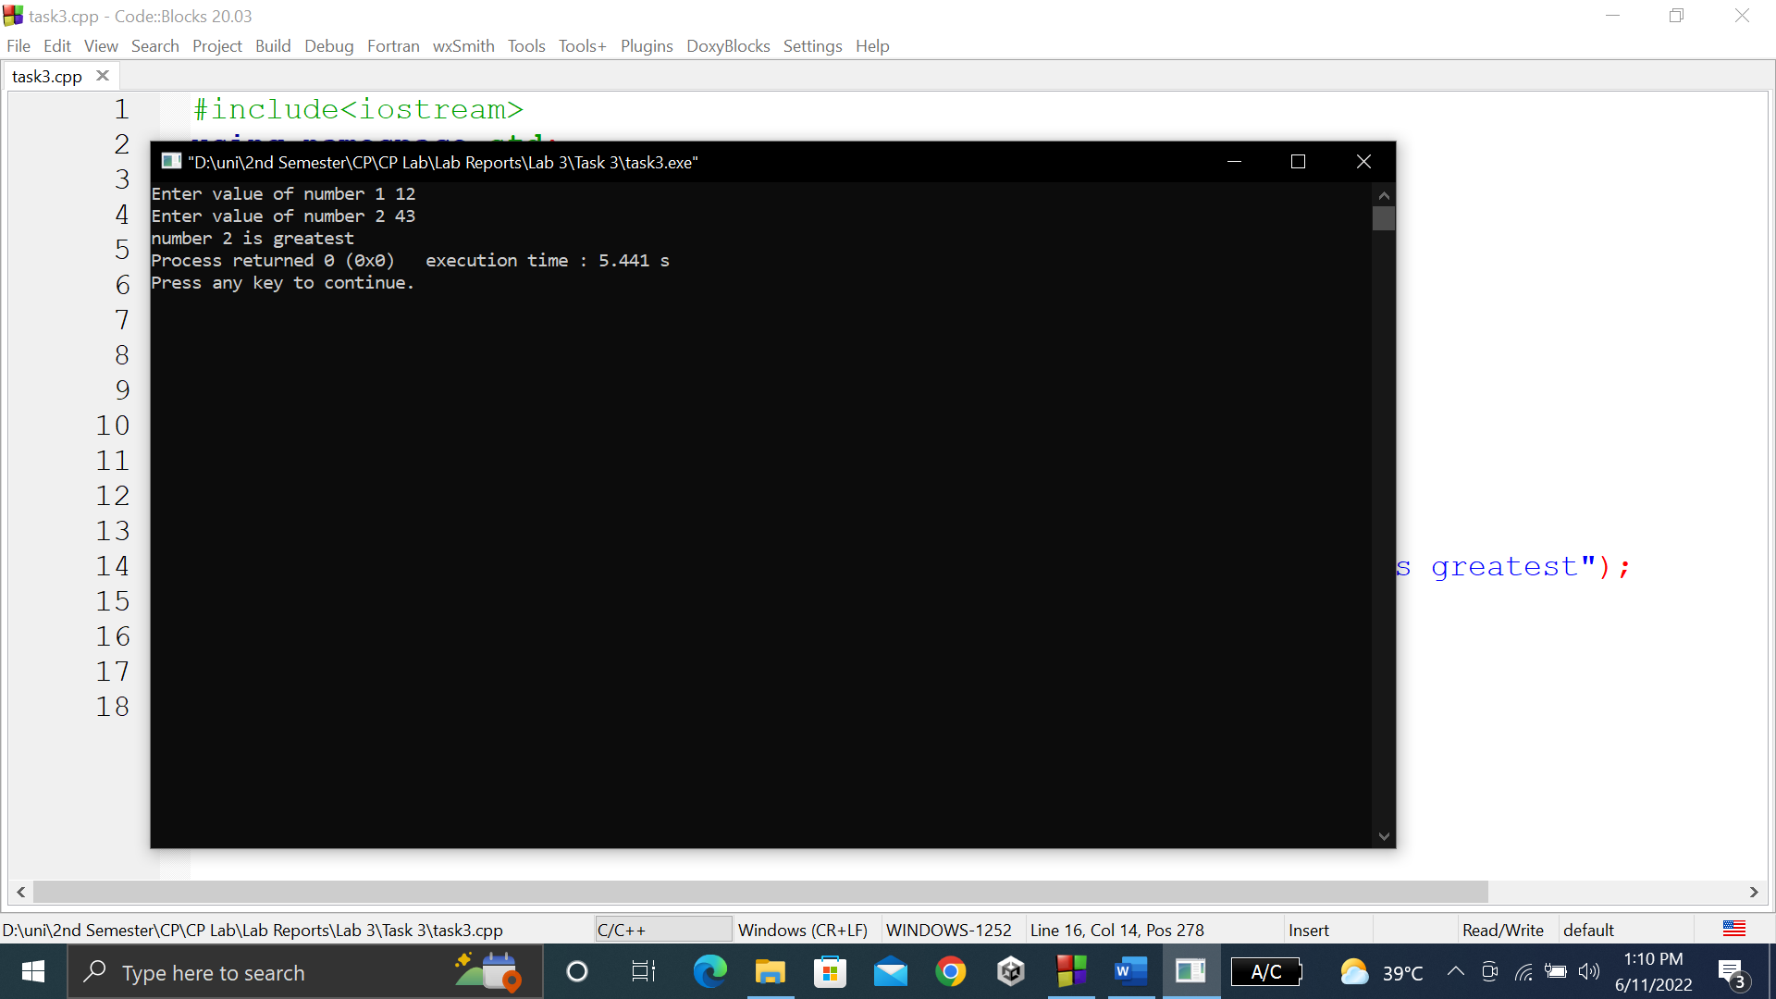

**TASK # 4:**

**Title:**

Write a program where you print you take a number from the user ……. 2 times or else print only 1 time.

**CODE SCREENSHOTS:**

Here is the screenshot of the code. Info is defined above main function.

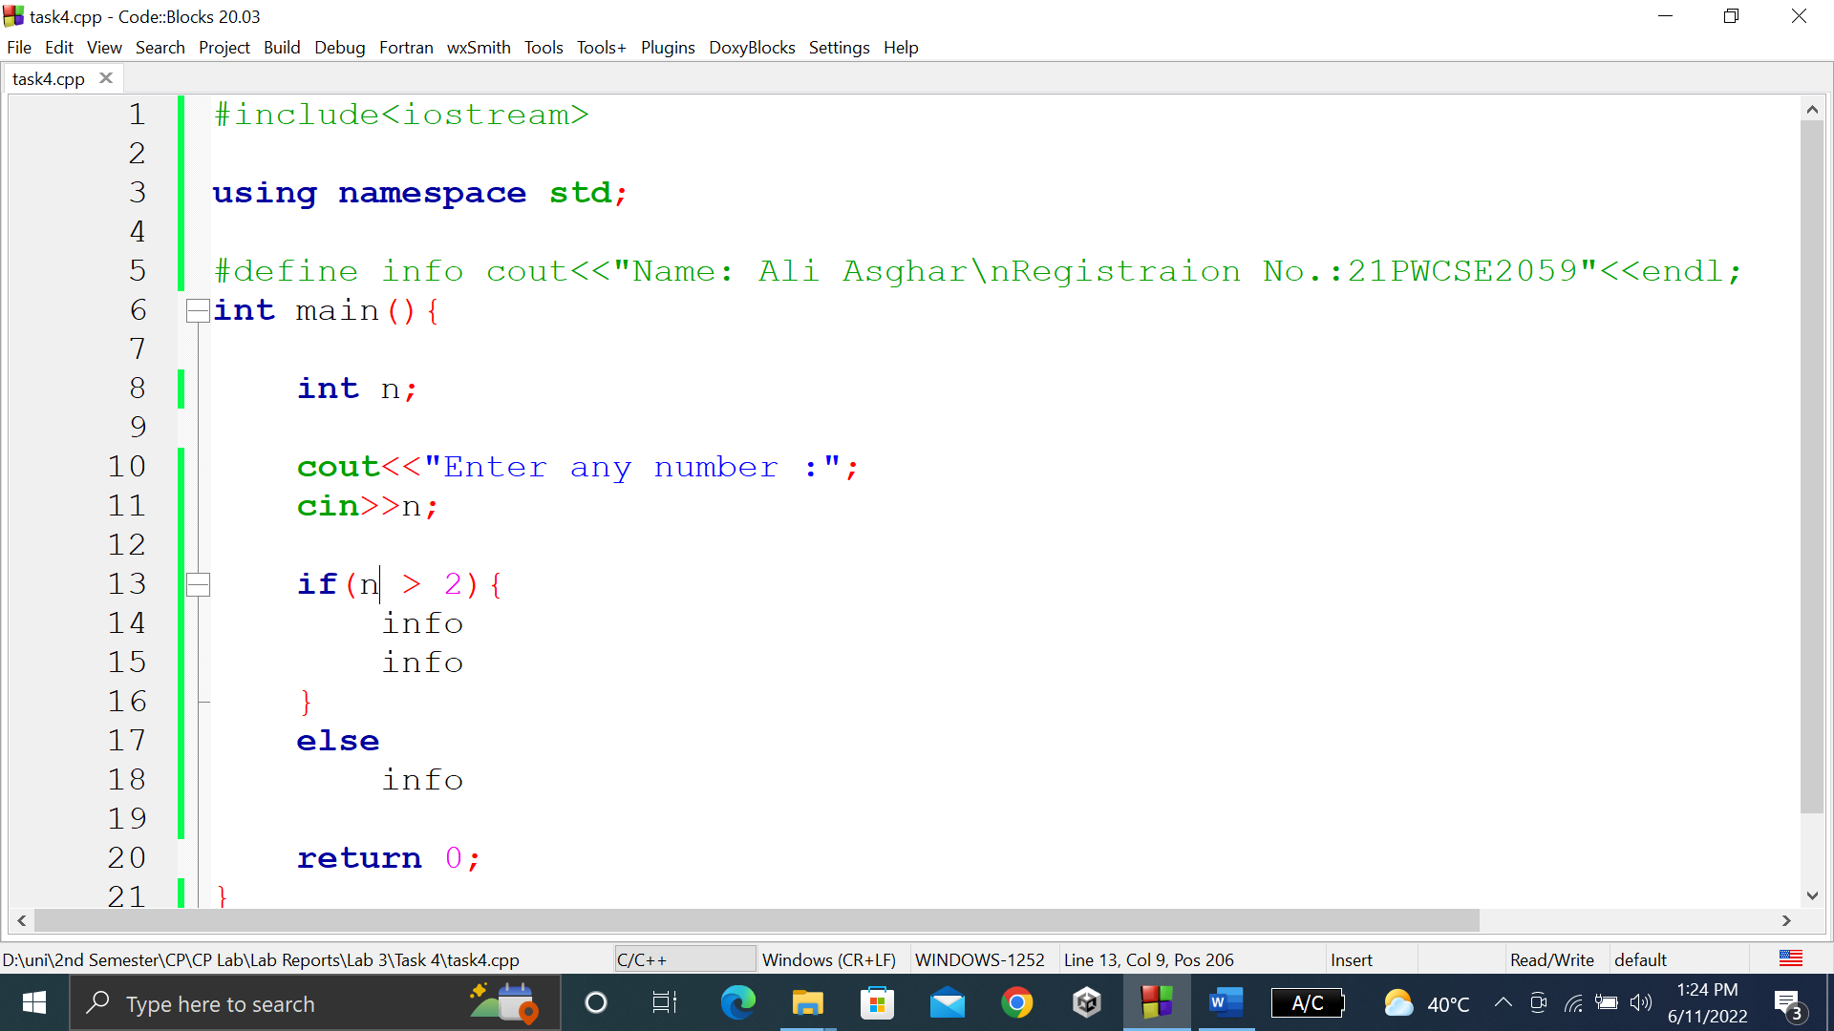

### **OUTPUT (COMPILATION, DEBUGGING & TESTING):**

Here is the screenshot of the output of above code.

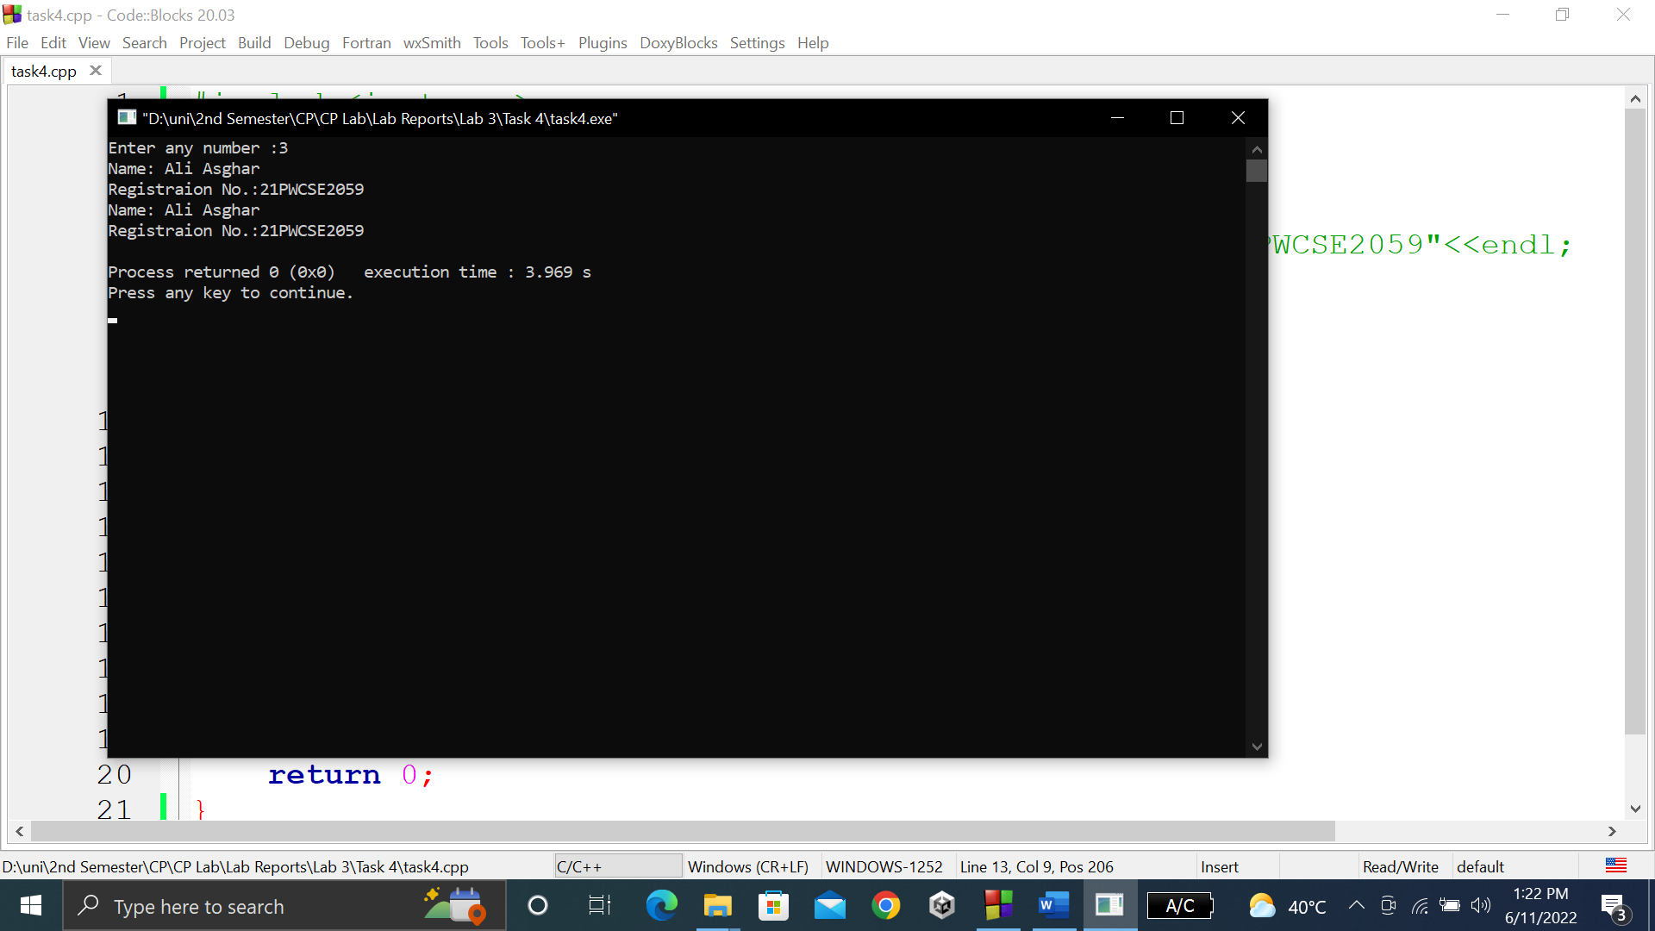

**TASK # 5:**

**Title:**

Write a program that asks a number and test the number whether it is multiple of 5 or not, divisible by 7 but not by eleven. (all three conditions should match)

**CODE SCREENSHOTS:**

Here is the screenshot of the code.

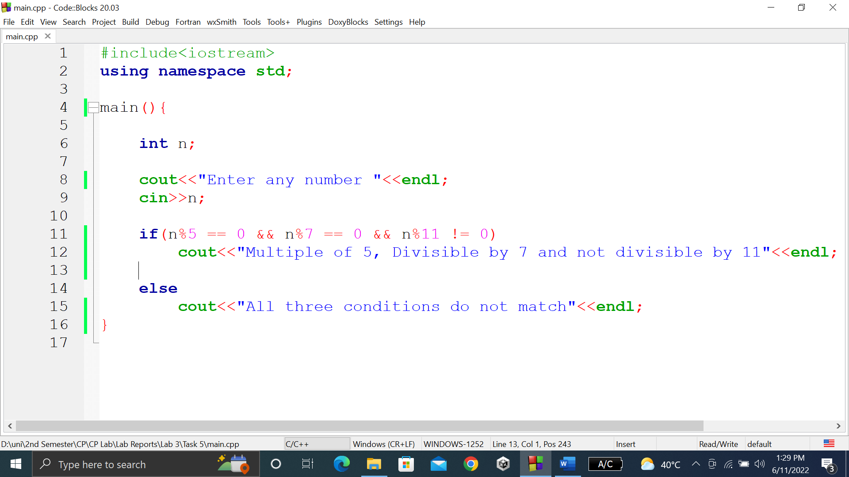

### **OUTPUT (COMPILATION, DEBUGGING & TESTING):**

Here is the screenshot of the output of above code.

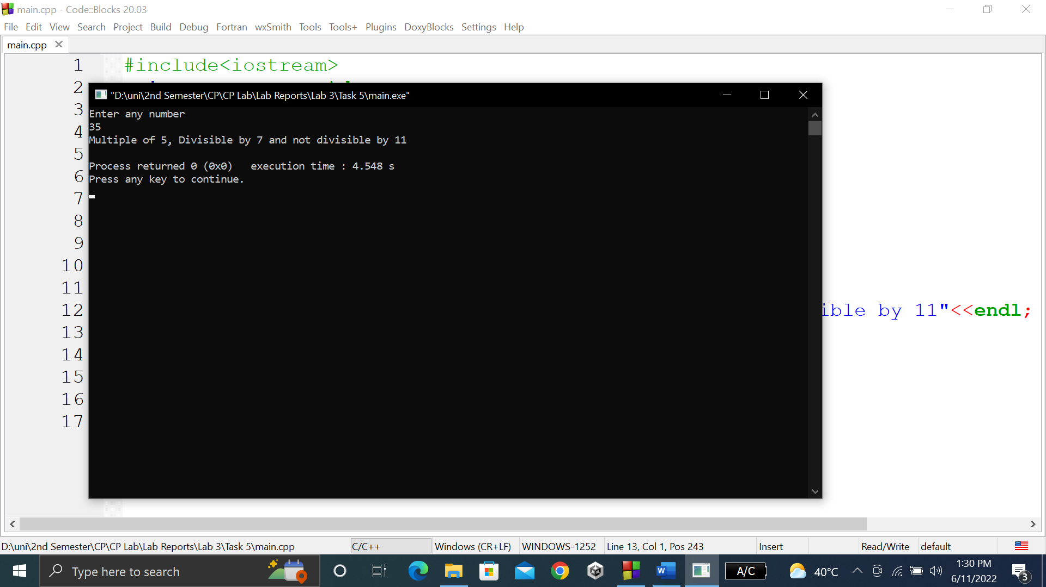

**TASK # 6:**

**Title:**

Check whether the entered character is vowel or consonant?

**CODE SCREENSHOTS:**

Here is the screenshot of the code.

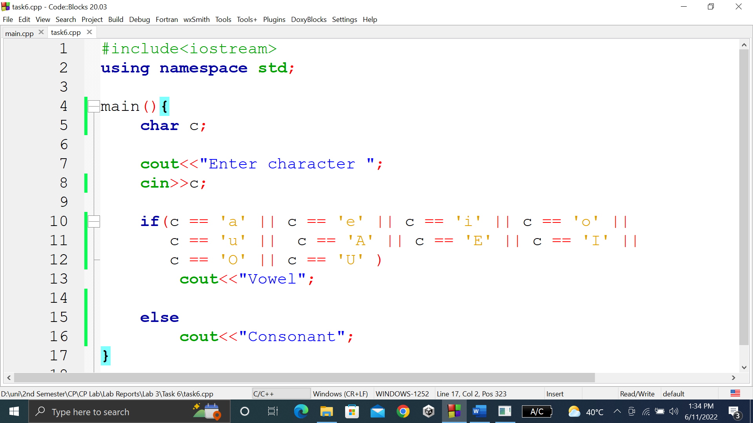

### **OUTPUT (COMPILATION, DEBUGGING & TESTING):**

Here are the screenshots of the output of above code.

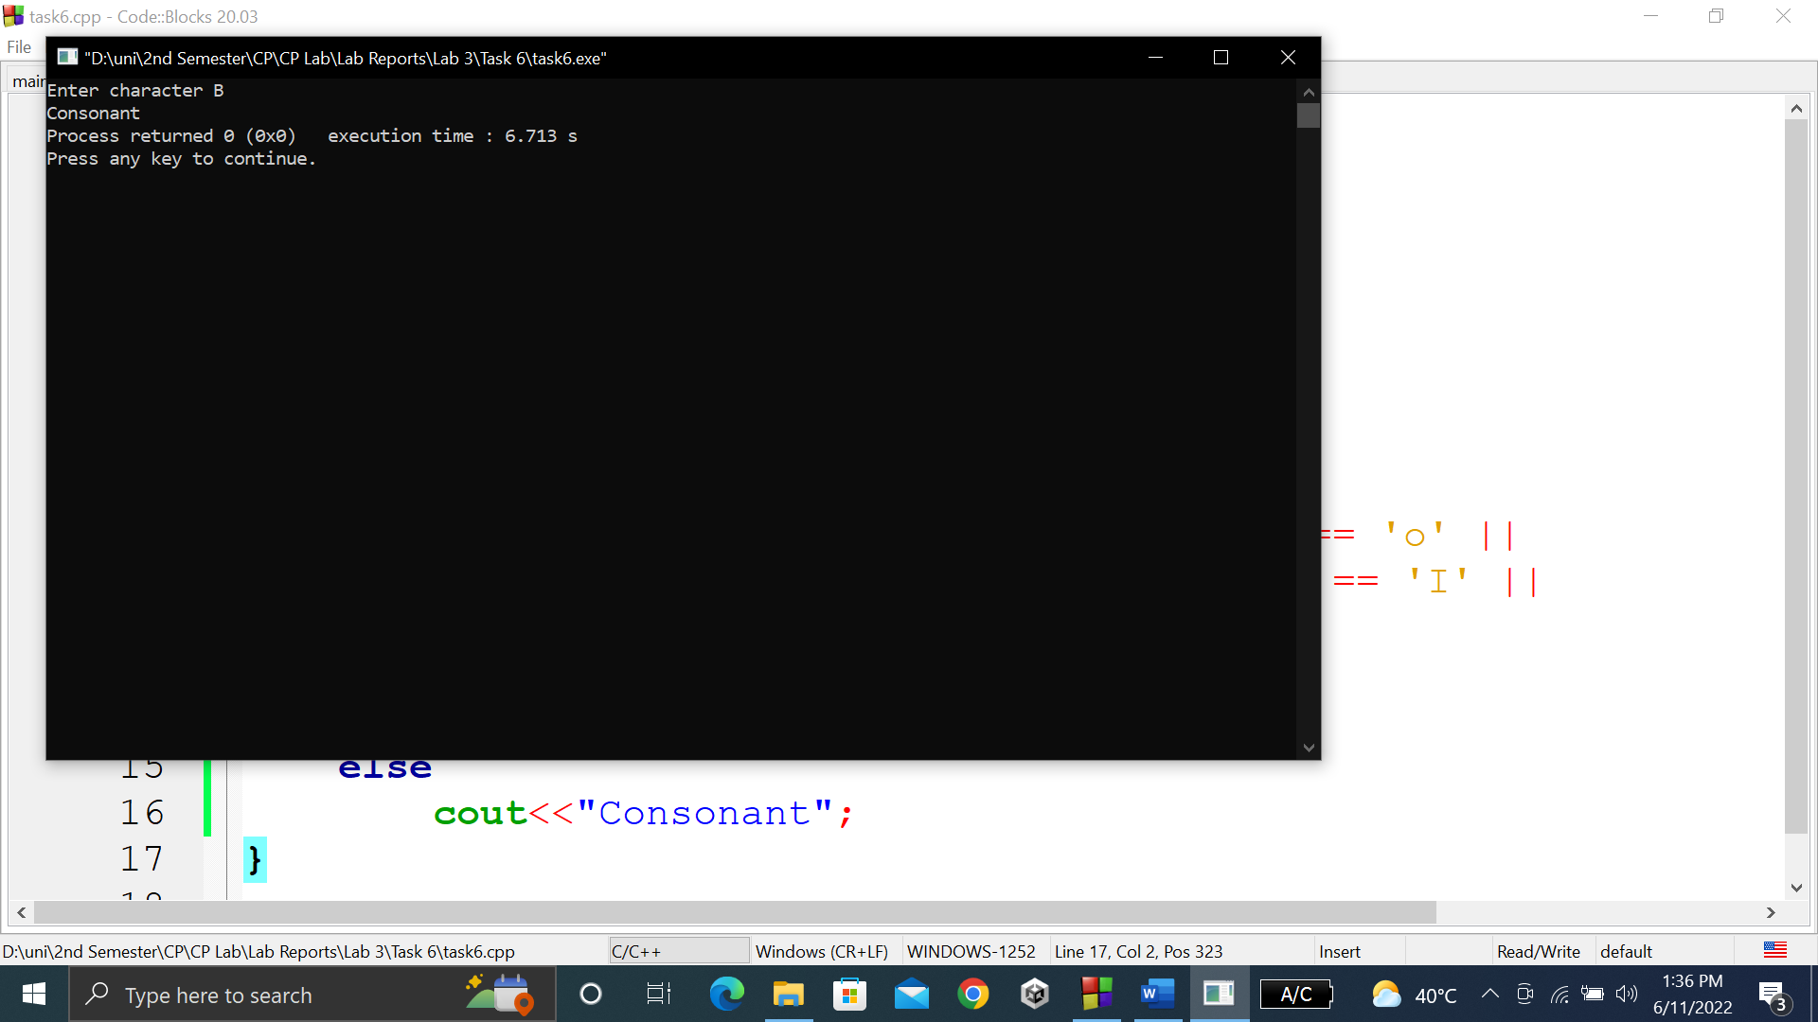

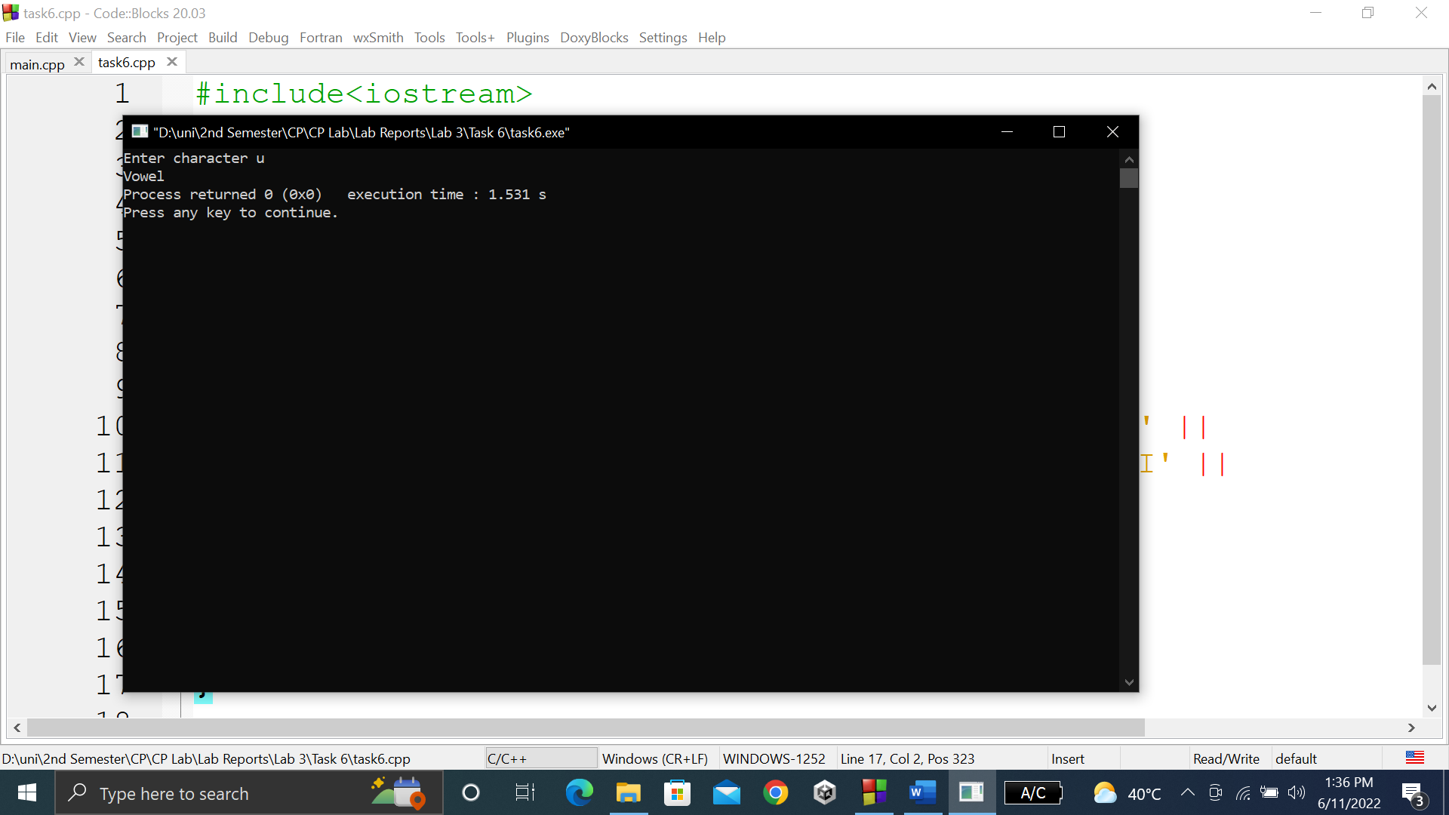

**TASK # 7:**

**Title:**

Write a program that takes the weekday number as input from user and print the day name of week

**CODE SCREENSHOTS:**

Here is the screenshot of the code.

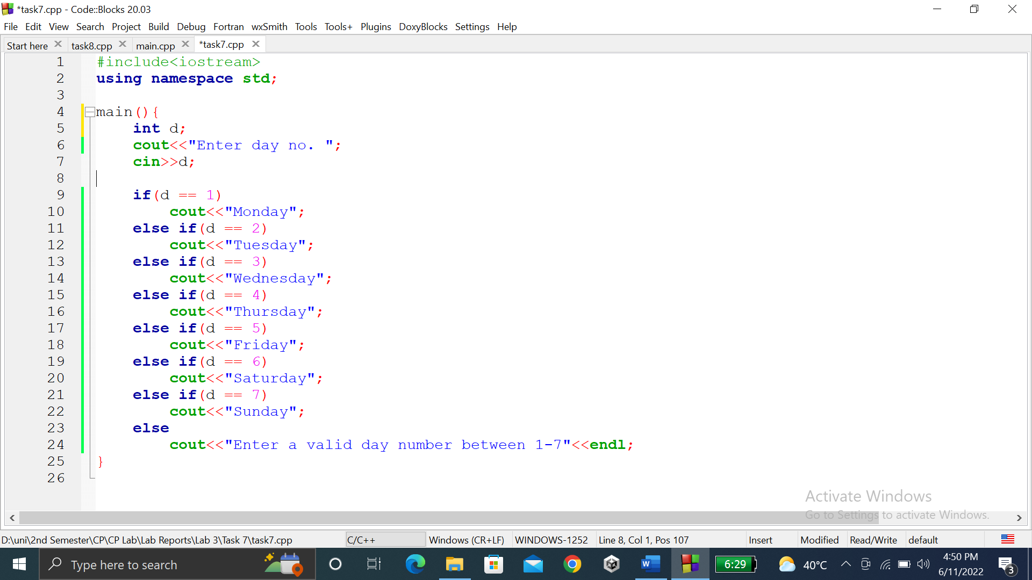

### **OUTPUT (COMPILATION, DEBUGGING & TESTING):**

Here are the screenshots of the output of above code.

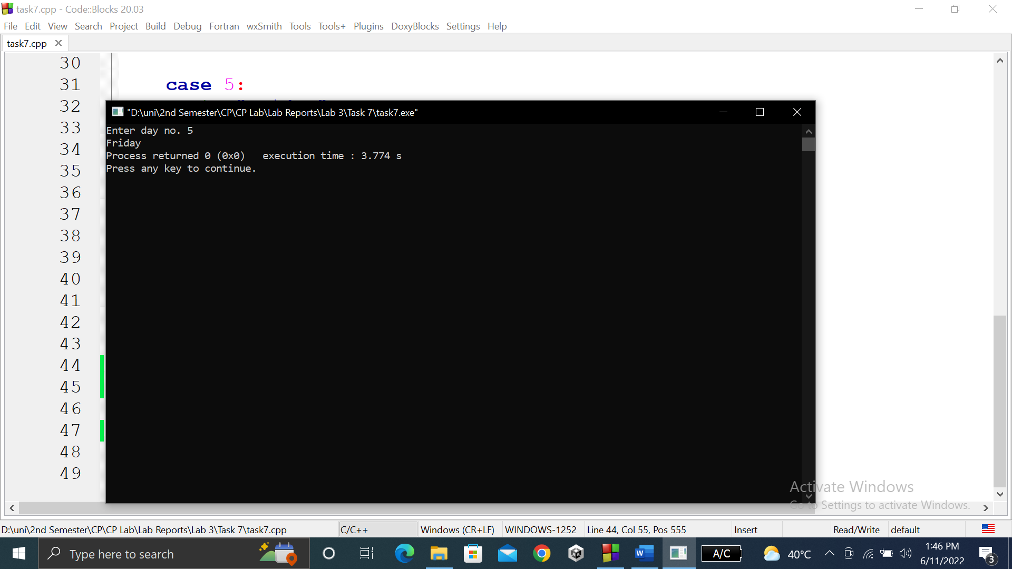

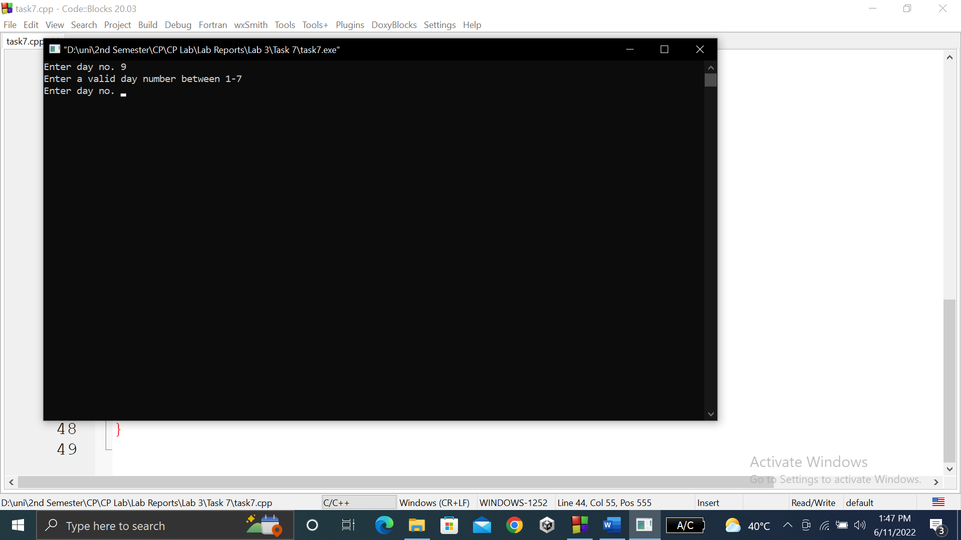

**TASK # 8:**

**Title:**

Write a C++ program to enter month number between (1-12) and print number of days in month.

**CODE SCREENSHOTS:**

Here is the screenshot of the code. Please note that I have defined a b and c above in the code for making code look smaller and concise.

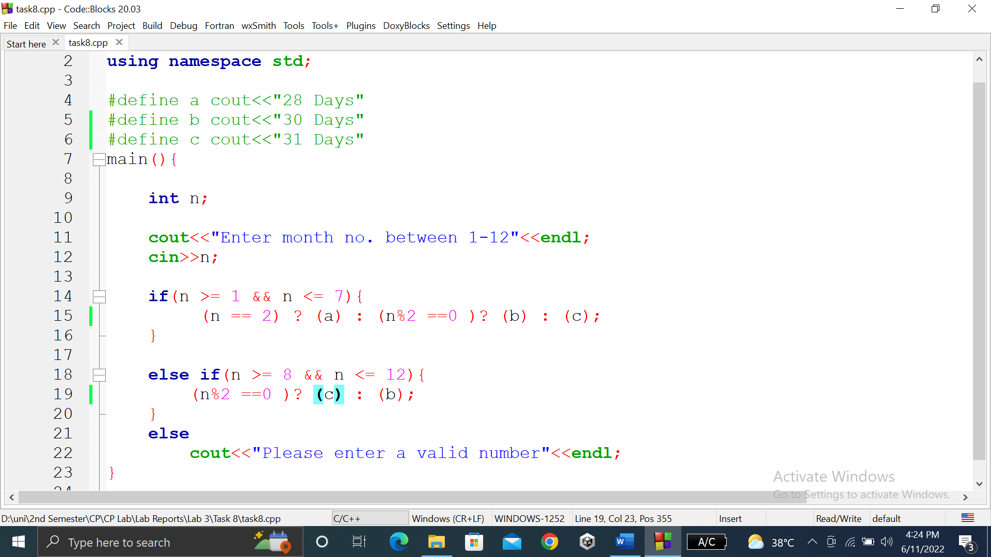

### **OUTPUT (COMPILATION, DEBUGGING & TESTING):**

Here are the screenshots of the output of above code.

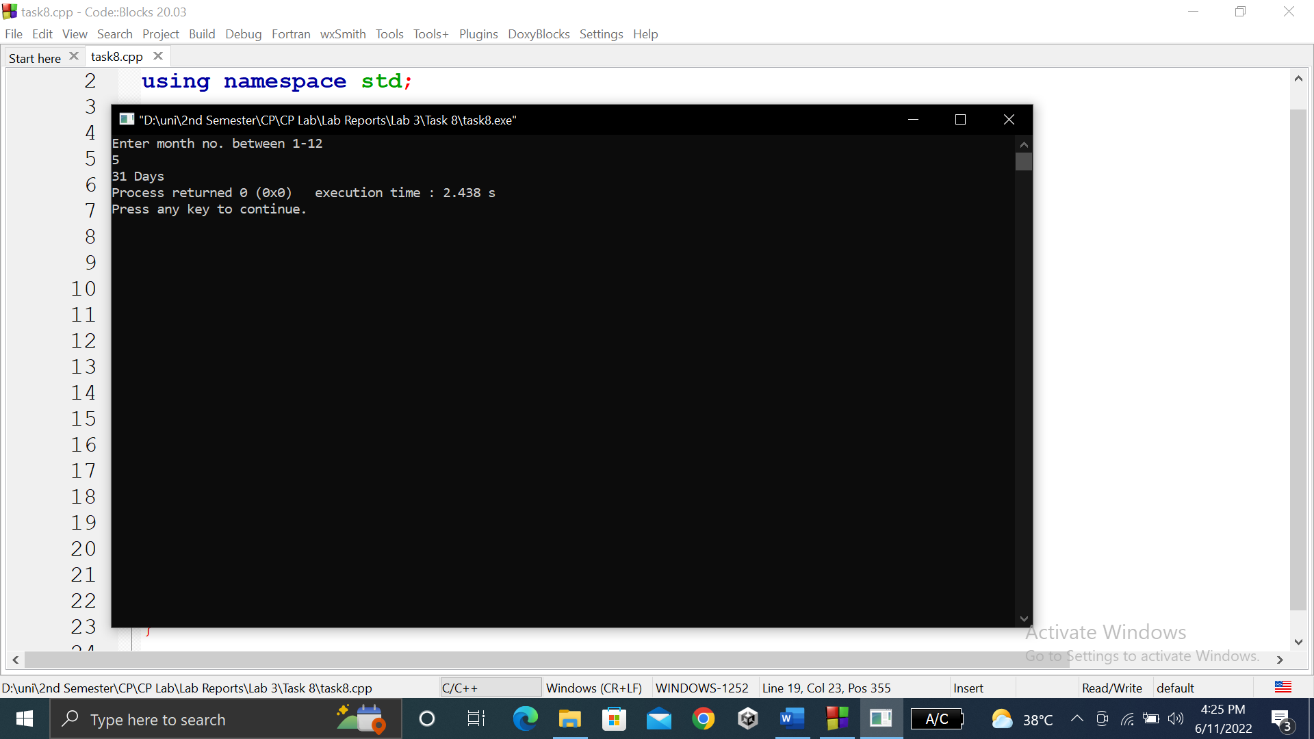

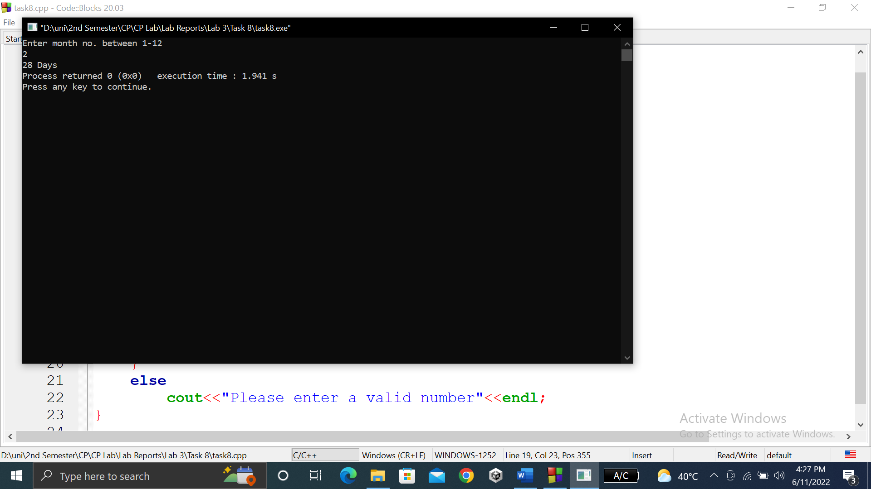

**TASK # 9:**

**Title:**

Write a program to calculate and print the Electricity bill of a given customer……..the customer.

**CODE SCREENSHOTS:**

Here are the screenshots of the code.

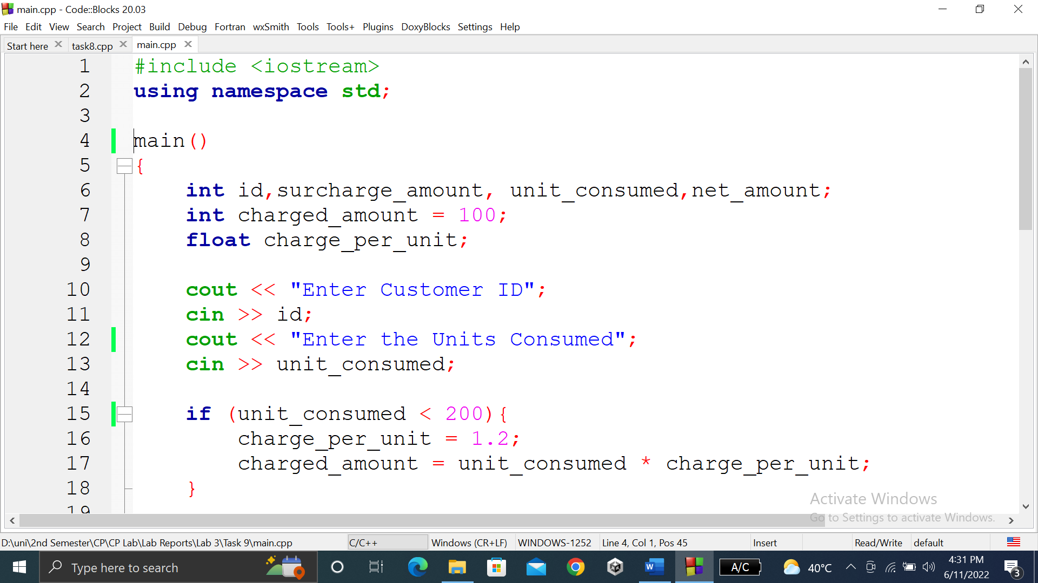

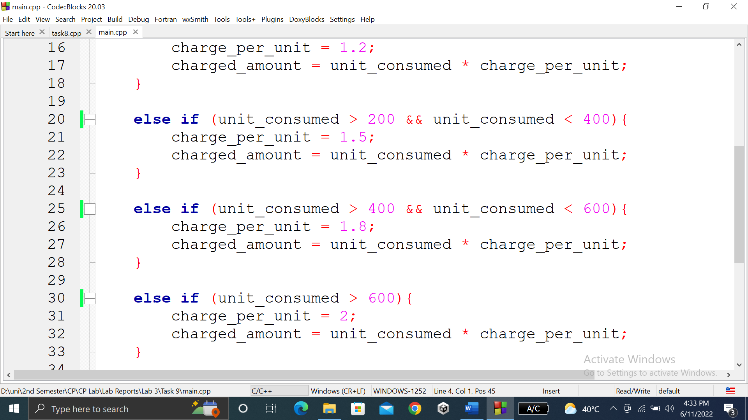

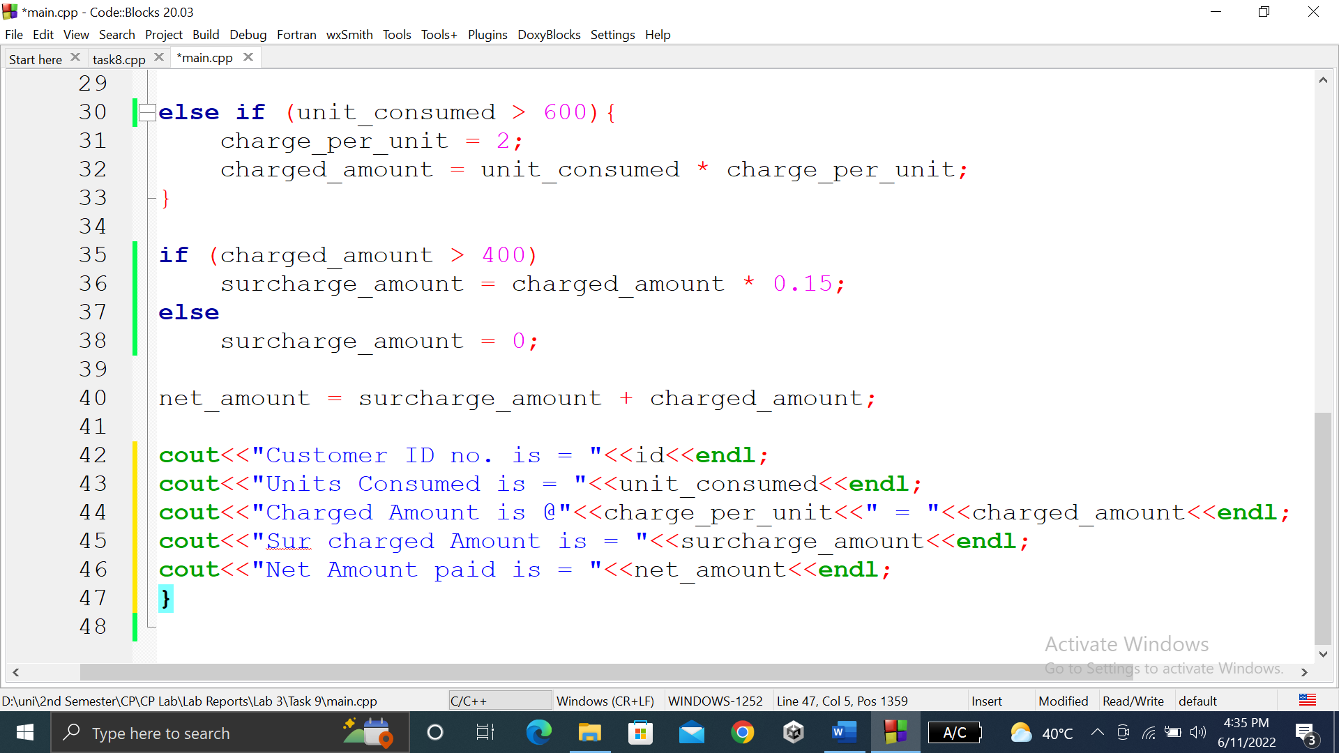

### **OUTPUT (COMPILATION, DEBUGGING & TESTING):**

Here is the screenshot of the output of above code.

